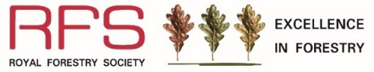
Education and Learning Award 2026
Entry Form
This award is open to self entry and nominations
Is this a self entry? ☐ or nomination? ☐
Self entry
Name of main contact
Name of organisation
(e.g. school, college, university, training provider, forestry learning organisation or other)
Postal address
Name of project or programme
Project/programme location
(Address/grid ref/w3w)
Tel / mobile number
Email address
Website (if applicable)

Nominated entry
Name of nominator
Nominator’s email
Nominator’s mobile number
Relationship to nominated organisation
I HAVE informed the organisation/project lead that I have nominated them. | Yes/No? | I WILL inform the organisation/project lead that I’m nominating them. | Yes/No?

Please answer the following questions as best you can (max. 100 words per question):
- To what extent has the project or programme increased the use of woodland and related industries for first-hand learning?
Projects will score highly if they provide opportunities for active learning in woodland settings; visits to related industry sites such as sawmills or wood product manufacturers; and/or where a hands-on experience has been provided in the school/college/university/training provider’s grounds.

Answer:

- To what extent has the project or programme increased the opportunity for students to learn about the importance of trees and forests for conservation of the environment?
Projects will score highly if they provide opportunities to learn about the critical role of the woodland environment such as its richness in biodiversity, landscape value and response to climate change.

Answer:

- To what extent has the project or programme increased the opportunities for students to learn about the link between trees and everyday wood products?
Projects will score highly if students are provided with an opportunity to learn about the social and economic benefits of wood as a sustainable resource, both locally and globally.

Answer:

- To what extent has the project or programme contributed to the development of skills and competency for learners?
Projects will score highly if they can demonstrate positive outcomes in terms of student development, attainment and/or introduction to careers appropriate for the age and type of group.

Answer:

In school/early years settings:
- To what extent does the project relate to the curriculum?
Projects or programmes will score highly if they link across a number of curriculum areas and whole school initiatives. A project or programme will also score highly if there is evidence that it is embedded into the school's teaching and learning rather than as an ‘add on’.

Answer:

- To what extent has the student community been involved in the project or programme?
Projects with student involvement in designing and planning, as well as implementation and reviewing of the project or programme outcomes will score highly.

Answer:

- To what extent has the wider community been involved?
Projects and programmes will score highly if they show that there has been communication and/or direct participation with parents, governors and the wider community.

Answer:

- To what extent does the project or programme have a lasting impact on the environmental/social and/or economic aspects of the school/community?
i.e. its overall sustainability.

Answer:

For colleges, universities and training providers
- To what extent does the project or programme engage new learners in forestry education, or provide new career development opportunities?
Projects and programmes that develop skills, reach new audiences, support career transition and employability are especially important to the forestry sector and will be viewed favourably by the judges. Projects that encourage new approaches to skills and professional development and safer working environments will be scored highly.

Answer:

For those entering themselves, please provide examples of student/learners’ work, photographs, videos and case studies.

Declaration and signature
I wish to enter the Education and Learning Award.
Signature

Date

Entry Form and supporting documentation to be sent by email (preferred) to: eif@rfs.org.uk or post to RFS Excellence in Forestry Awards, The Hay Barns, Home Farm Drive, Upton Estate, Banbury, OX15 6HU.

Closing Date for Entries: 30 April 2026
Education and Learning Award 2026 is sponsored by Duchy of Cornwall and PEFC
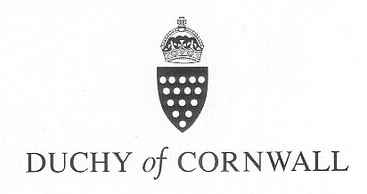 | 