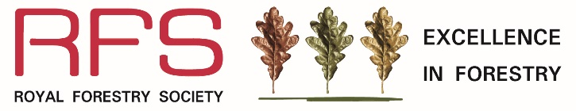

The Bede Howell Award for Excellence in Silviculture

2026

Name of main contact
Postal address
Tel / mobile number
Email address
Relationship to property / woodland (eg. owner, forester, agent)

Name of property/woodland
Total area of woodland (min. 2 hectares)
Name of owner
Name and address of owner (if different to main contact)
Tel / mobile number
Email address
Location of woodland
Nearest town
Details of rendezvous point (RVP) for site visit
RVP OS grid reference (e.g. SH123987) and postcode
What Three Words – reference if known

Supporting information required
500-word statement - A separate statement of about 500 words should be supplied, starting with the objectives of management. It should give details of the management of the woodland for the production of high-quality timber, or other commercial products, and indicate the outlets for the products marketed. Any woodland management practices aimed at maintaining or improving landscape, biodiversity, recreation or education should also be described. Please refer to the Bede Howell Award for Excellence in Silviculture Rules & Guidelines and show how the wood meets the eligibility and judging criteria. Entries that do not meet the eligibility criteria will not be shortlisted.
Map - A map at 1:50,000 scale should be supplied, showing the area entered and the RVP clearly marked. Other larger scale maps can be included in support of the statement.

Declaration and signature
I wish to enter the Bede Howell Award for Excellence in Silviculture
Signature

Date

Entry Form and supporting documentation to be sent by email (preferred) to eif@rfs.org.uk or posted to RFS Excellence in Forestry Awards, The Hay Barns, Home Farm Drive, Upton Estate, Banbury, OX15 6HU.

Closing Date for Entries: 30 April 2026

The Bede Howell Award for Excellence in Silviculture 2026
is sponsored by Tilhill Forestry

