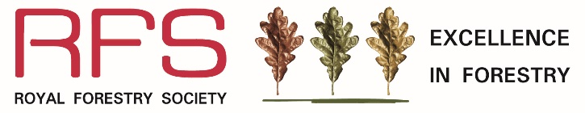
Education and Learning Award
2025
Name of nominator

Nominator’s contact details

Relationship to nominated organisation

Name of main contact
(e.g. Head teacher, tutor, director)

Name of organisation
(e.g. School, colleges, universities, training provider)
Name of Project or Programme
Postal address
Tel / mobile number
Email address

Statement (no more than 500 words)
Please explain why this project or programme deserves to be awarded the Excellence in Forestry Award for Education and Learning. Please describe how the project/programme increases awareness, understanding and skills related to the environmental, social and economic potential of trees, woodlands and forests. Where possible please demonstrate how the project/programme is innovating.

Optional – if you are able to, please provide any examples of student/learners’ work, photographs, videos or case studies.

Please email this form to: eif@rfs.org.uk or post to RFS Excellence in Forestry Awards, The Hay Barns, Home Farm Drive, Upton Estate, Banbury, OX15 6HU.

Closing Date for Entries: 30 May 2025

Education and Learning Award 2025
is sponsored by Duchy of Cornwall and PEFC
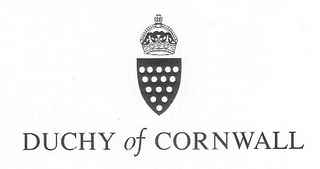 | 