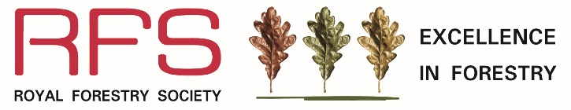

Community Woodland of the Year Award

2024

Name of entrant
Postal address
Tel / mobile number
Email address

Name of property/woodland
Total area of woodland (max. 200 hectares) *
Name of owner
Name and address of contact (if different from above)
Tel / mobile number
Email address
Location of woodland
Nearest town
Details of rendezvous point (RVP)
RVP OS grid reference (e.g. SH123987) and postcode
What Three Words – reference if known
*where the woodland exceeds 200 hectares, the owner should designate a representative block or coherent unit up to a maximum of 200 hectares and show this clearly on the map.

Supporting information required
500-word statement - A separate statement of about 500 words should be supplied, starting with the objectives of management. It should give details of steps taken in the establishment and management of the woods and trees entered to maintain and encourage two or more of the following: landscape and environmental improvements; benefits to people (e.g. health and well-being, education and training, sport and recreation); strengthening communities; and enhancing biodiversity. Please refer carefully to the Community Woodland of the Year Award Rules and Guidelines and show how the project meets the eligibility and judging criteria. Entries that do not meet the eligibility criteria will not be shortlisted.
Map - A map at 1:50,000 scale should be supplied, showing the area entered and the RVP clearly marked. Other larger scale maps can be included in support of the statement.

Entry fee
The entry fee is £25.00. Payment method (please tick box):
Cheque – made payable to ‘Royal Forestry Society’ please post to RFS HQ (address below)
Debit or Credit card – please telephone RFS Head Office on (01295) 678 588 (quoting ref. EIF)
Bank transfer – Barclays Bank, Account Name: Royal Forestry Society, Sort Code: 20-39-07, Account number: 60771023 (please put EiF in your reference)

Declaration and signature
I wish to enter the Community Woodland of the Year Award.
Signature

Date

Entry Form and supporting documentation to be sent by email (preferred) to eif@rfs.org.uk or posted to RFS Excellence in Forestry Awards, The Hay Barns, Home Farm Drive, Upton Estate, Banbury, OX15 6HU.

Closing Date for Entries: 30 April 2024

Community Woodland of the Year Award 2024
is sponsored by the Woodland Trust
